WEST LONDON WASTE AUTHORITY
Report of the Managing Director | 23 September 2022
WLWA Business Plan

SUMMARY
This report provides details of the Authority’s Business Plan for 2022/23. The key points are:
- WLWA and Boroughs made a very strong and collaborative response to Covid 19 which has speeded up progress in our collaborative working. Collectively we understand the objectives and targets in the Joint Municipal Waste Management Strategy (JMWMS).
- WLWA and Boroughs are waiting for; a government response to the 2021 consultations on waste prevention, consistency and deposit return schemes, and Regulations to follow the Environment Act 2021 on these consultations and extended producer responsibility for packaging. Several more consultations emerged and were responded to in 2022. This is all crucial information to inform our route map to deliver the JMWMS.
- We have agreed to create a joint plan for 2030 which will provide a draft route map and which can be amended as legislative clarity emerges. This joint plan allows WLWA to plan ahead for e.g. data, land or infrastructure needs the Boroughs may have for waste and recycling in the future and to offer synergies and economies of scale.
- The WLWA business plan 2022/23 has three key themes to prepare us for the significant changes ahead: Resilience and preparation, Projects and Investments and Communicating the Vision. Our values of Leadership, Empowerment, Agility and Partnership are key drivers of our ambition to be an organisation that delivers more than the sum of our parts.
- The strategic objectives of every individual in the organisation are visible to everyone working in the organisation, including progress towards milestones which are self-reported. This software was introduced in July 2022 and the first review will take place by the end of September 2022.
RECOMMENDATION(S)
The Authority is asked to:-
- Approve the Business Plan activities for inclusion in the annual report
- Approve the framework for the Joint Plan for 2030 in section 4

- Background – During several years of fast moving change the West London Waste Authority business plan has focused on outcomes. The organisation has developed and cemented within the organisation its values of Leadership, Empowerment, Agility and Partnership to support these outcomes. In 2021 WLWA published its first annual report, designed to bring together all of the challenges and successes of the previous year. The business plan will be incorporated into the 2022 report.
- Statutory, national and London targets have set the scene for the first few years of our joint municipal waste management strategy whilst we wait for the Regulations that follow the Environment Act 2021:
- Carbon neutral by 2030
- 65% municipal recycling: by 2035 (UK Government target) by 2030 (GLA target)
- Net-zero greenhouse gas emissions: by 2050 (UK Government target) by 2030 (GLA target)
- Zero vehicle emissions by 2050
- The impact of the Covid 19 pandemic was to speed up the progress of some Business Plan activities and render others obsolete due to increased collaborative working with Boroughs which created new priorities. Boroughs needed to mitigate the cost of increased tonnage through the household collection systems due to increased home working. Booking systems introduced to manage the impact of social distancing at HRRCs demonstrated improved communication with residents and identified missed opportunities to recycle and reuse on sites. Joint working on data, waste minimisation, food waste projects and HRRCs all increased and projects were speeded up where possible. WLWA successfully adapted to manage Covid 19 safely and all business as usual activities were completed on time.
- Collaborative working has continued post pandemic. In 2021, the project areas previously identified by WLWA in 2019 were replaced by six programmes of work each headed by one WLWA Councillor and one Environment Director from a different Borough. This innovative method of working resulted in a suite of WLWA policies approved in March 2022. A strategy away day in March 2022 created a framework of a joint plan for 2030 to be developed by WLWA and Boroughs investigating the risks and opportunities, and the financial, management information and skills implications of the changes to come for the waste and resources sector.
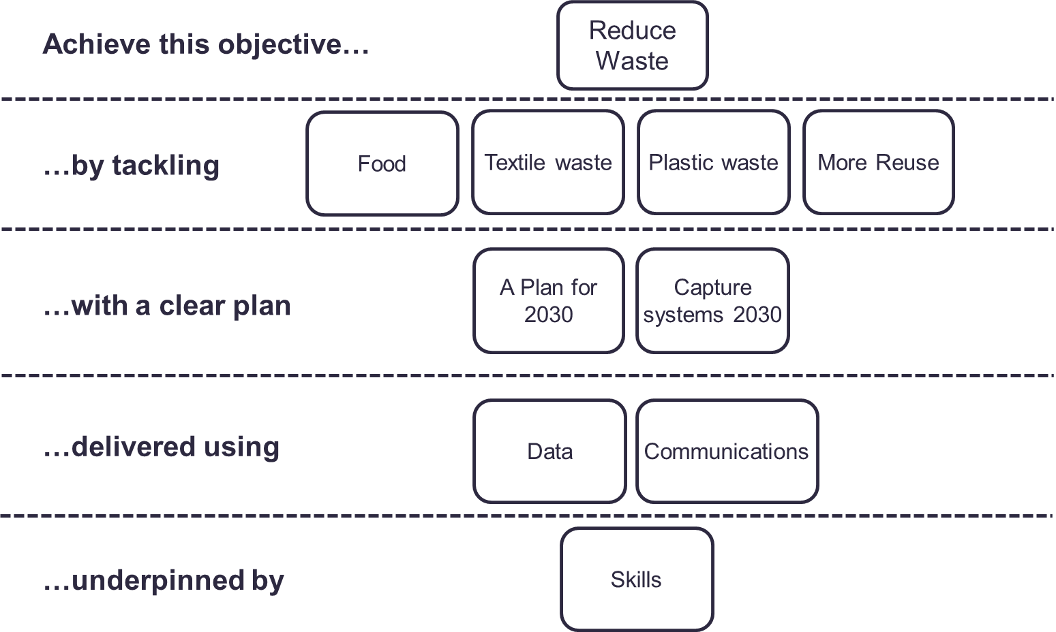
- Legislative delays – The Environment Act was delivered 6 months later than expected in Dec 2021. Defra has published a response to the consultation on Extended Producer Responsibility for packaging consultations but delayed introducing EPR for business waste which is a significant missed opportunity to increase recycling. The responses to the consultations on Consistency and Deposit Return Schemes have not yet been published over one year after the consultations closed.
- Recent Consultations have been published on digital waste tracking, reform to carriers, brokers and dealers regulations, removing charges for “diy” waste at recycling centres (HRRCs) and including energy from waste facilities in the Emissions Trading Scheme (ETS). The ETS could increase costs by around £36 per tonne, a significant cost increase to every Borough per annum. WLWA has created a finance strategy to provide investment in waste reduction and to support increase in Borough recycling services in mitigation.
- New software was introduced in July 2022 by the HR Manager which allows all employees’ strategic objectives to be self-input to the software, all strategic objectives are linked to the organisations strategic goals and visible to all employees. Progress updates are self-reported and visible to all employees. Prior to going live in July 2022, regular whole team meetings drove the knowledge and training required to create whole organisation goals in this empowered and collaborative method. The first review period is before the end of September 2022. The Managing Director’s three strategic objectives to which all employees’ strategic objectives are linked are: Resilience and preparation, Projects and Investments and Communicating the Vision.
The business plan activities are detailed on the next page.

- Business Plan 2022/23
  - Resilience and preparation
WLWA must be prepared for significant change resulting from legislation and social and economic needs. We must remain aligned with our supply chain and Boroughs as all organisations in the resources and waste sector manage significant change.
Item | Responsible Owner | Progress to date | Outcome
Training / development opportunities for core skills are prioritised. | Managing Director | Insights training for all employees carried out and ongoing.  Coaching training for all employees carried out and ongoing.  Lean Six Sigma white belt for most employees carried out.  Data driven decision making training carried out for Managing Director and Finance Director. Power BI training carried out for MI Team. | Skills plan updated and delivered
Chair West London Climate Emergency Officers Group | Managing Director | Industry webinars carried out. Presentation opportunities secured with CIWM and Future Places conference. | Presentations to WL CE Board and Leaders Board, webinars and conferences.
A Joint Plan for 2030 | Head of Service Delivery | Draft legislative risk assessment created. | Risk Assessment  Timetable  Legislative matrix  5 year MTFS
Develop an HR Strategy | Finance Director | Initial scoping considered with leadership and completion planned for Q4 | HR Strategy
Prioritising Lean Six Sigma and Data driven decision making for HRRC projects | Head of Service Delivery | Lean Six Sigma and Data Driven Decision Making skills/culture roll-out plans developed.  Dashboard developed for monitoring HRRC improvements | Training outcomes
Attend and present at West London Treasurer meetings | Finance Director | Regular Finance Updates and strategic information shared at quarterly meetings | 5 year MTFS  WLT support for the Joint Plan for 2030
Build partnerships through collaborative procurements | Procurements and Contracts Manager | Procurements delivered for waste transport, green waste management and rubble management, all with a strong carbon and social value focus, and leading to savings. | Economies of scale, circular economy, low carbon and social value outcomes
Theme lead for pan-London Reducing Consumption Emissions programme | Project Manager  (E Hall) | Theme lead activities ongoing | Develop complimentary WLWA e-waste and textiles strategies

  - Projects and Investments
WLWA has invested £3m in food waste projects and £1.2m in HRRC recycling and reuse projects. We must demonstrate the waste reduction and recycling outcomes and build trust in future investment programmes.
Item | Responsible Owner | Progress to date | Outcome
WLWA Finance Strategy. | Finance Director | Finance Strategy agreed with West London Treasurers and draft presented to WLWA Members in June 2022 | Agreed Finance Strategy
Optimise income from the PPP contract | Finance Director | Work and negotiations ongoing to scrutinise income sources on the contract. | Investment in WLWA and Borough projects
Infrastructure Investment Plan | Finance Director | To be commenced Q3 | Draft Infrastructure investment plan
Food Waste Programme | Projects Director | Investments made, KPIs established.  Waste composition booked for Sept 2022. | Reduced food waste and / or increased recycling
HRRCs waste diversion programme | Operations Manager | Detailed plans improvement plans developed for two Boroughs. Plans under development for other Boroughs. | Reduced waste and / or increased recycling
Prepare for Consistency, EPR and DRS impacts on Boroughs | Senior Project Manager | Mapping software purchased  Modelling commenced in one Borough | Digital twin of collection system
Create a joint Extended Producer Responsibility Strategy with Boroughs | Projects Director | To be established through Environment Directors and West London Treasurers Boards | Agreed Joint EPR Strategy

  - Communicating the Vision
WLWA must ensure the link between waste and climate is understood, build partnerships, articulate what success looks like and discuss the steps and challenges with Boroughs and supply chains along the way.
Item | Responsible Owner | Progress to date | Outcome
Circular Economy Hub at Abbey Road | Projects Director | Operational with multiple materials offtakers and fixing factory workshops.  Social value analysis underway. | CE Hub to communicate the vision in Brent
Borough Circular Economy Hub | Projects Director | Business Case and design stage for Ealing  Inclusion in project team for Harrow and Hounslow.  Scoping opportunities in remaining Boroughs | CE Hub to communicate the vision in Borough(s)
Create a virtual circular economy hub | Net Zero Carbon Manager | New website launched in June.  The Electric Repair Directory is incorporated on the website listing +100 local businesses.  New contractor to develop the website appointed at the end of August. | Online virtual CE Hub
Lead WLWA Strategy Away Days | Head of Service Delivery | First strategy away day delivered on 25 March. | Progress on the joint Plan for 2030  First draft / outline of a new JMWMS
Procure a communications project to measure baseline and improve levels of understanding in West London of the link between climate emergency, waste and resources. | Net Zero Carbon Manager | Draft options appraisal for discussion  Soft market testing underway | Communications Agency Programme

- Financial Implications – The most substantial cost risk is the inclusion of energy from waste facilities in the emissions trading scheme which could effectively tax WLWA for waste produced by our residents and do so in an unpredictable market. This business plan supports our financial principles of reducing costs, providing stability around WLWA levies, effective management of financial risk and where appropriate, creating infrastructure and collaborative projects with Boroughs. The aim will be to continue providing long term stability and predictability as per the finance strategy.
- Risk Management – Individual projects carry risks of change. These risks will be considered on a project by project basis.
- Health and Safety Implications – Health and Safety considerations form part of the operational management and project development processes.
- Legal Implications – The Regulations to follow the Environment Act 2021 have not yet been published and will be crucial to developing a long term strategy.
- Impact on Joint Municipal Waste Management Strategy – included in the report.

Background Papers
 | Emma Beal | Managing Director | 07766 147 978
 |  | emmabeal@westlondonwaste.gov.uk

